Scaled at 100% instead of recommended 150% & expanded actions due panel
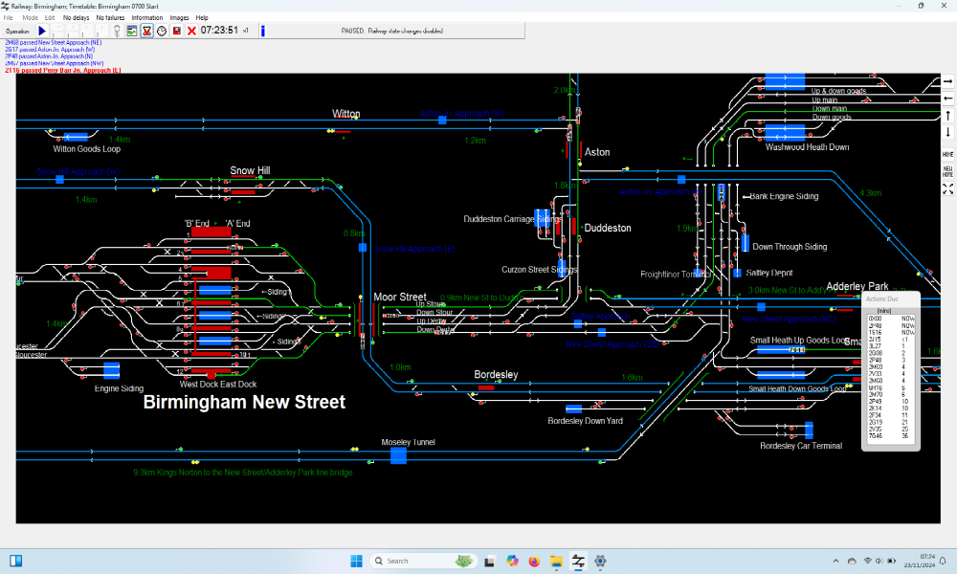

Scaled at 150% (recommended ) & expanded actions due panel
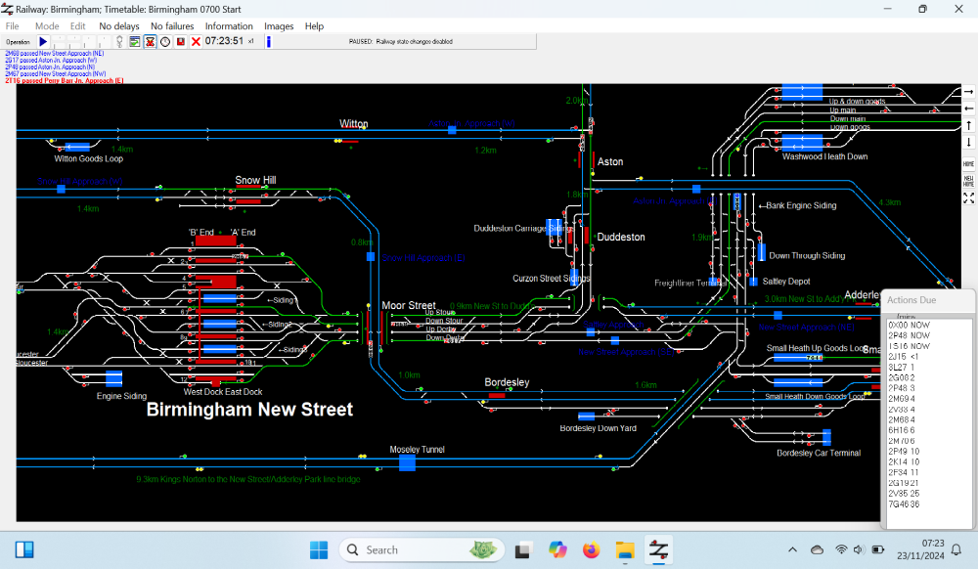

Original on Win 10
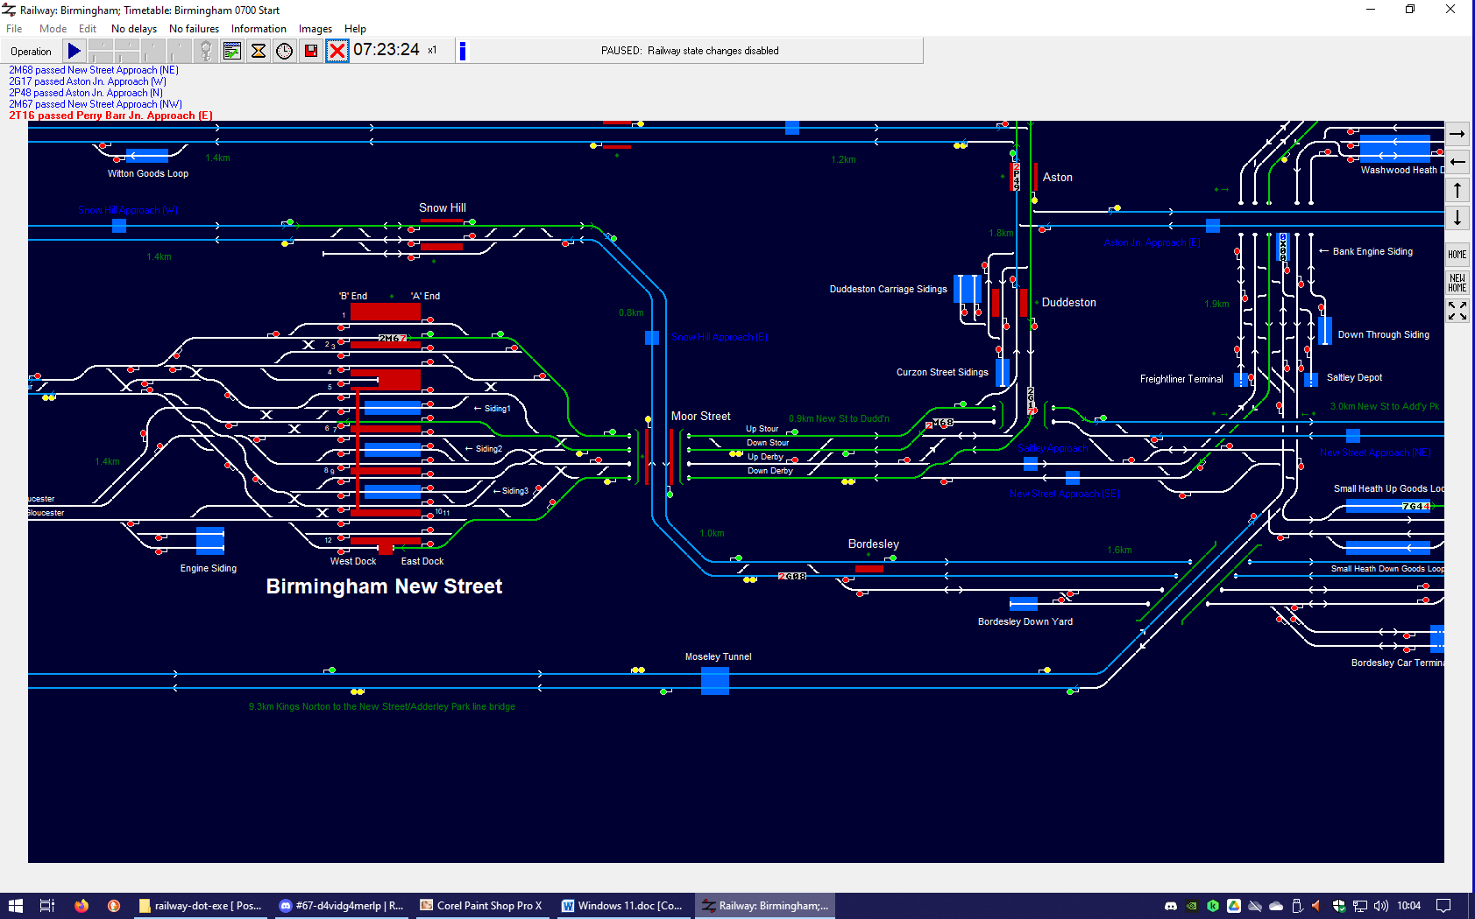
On Win 11 the text in actions due panel and title + menu names + performance panel all change with scaling, but not that on screen or in the 10 warnings at top left. Displayed screen bigger on Win 11 but that's probably due to screen resolution being higher. But the text size on screen is bigger than Win 10 regardless of scaling.
With taskbar hidden Win 11 flashes much more when screen moved with mouse and when trains move, and when routes being set as it does in Win 10. But with taskbar showing, or when screen not maximised, there's no flashing on Win 10 or Win 11
Perf panel cropped at bottom, made resizeable like actions due panel so can have full height viewable

